

Programmes Funding Officer

## Job Pack August 2024

We are looking for a Programmes Funding Officer to join the Able Child team!

We are a small, inclusive team that cares passionately about diversity and representation, but we acknowledge we can always be improving.

We actively encourage applicants from all backgrounds. We particularly encourage applications from people with disabilities or with direct experience of living or working with children with disabilities. All applicants with a disability who meet the minimum criteria will be offered an interview.

We also encourage applicants from African diaspora or heritage and people from Black, Asian and Minority Ethnic backgrounds.



Working for children with disabilities in Africa.

## About us

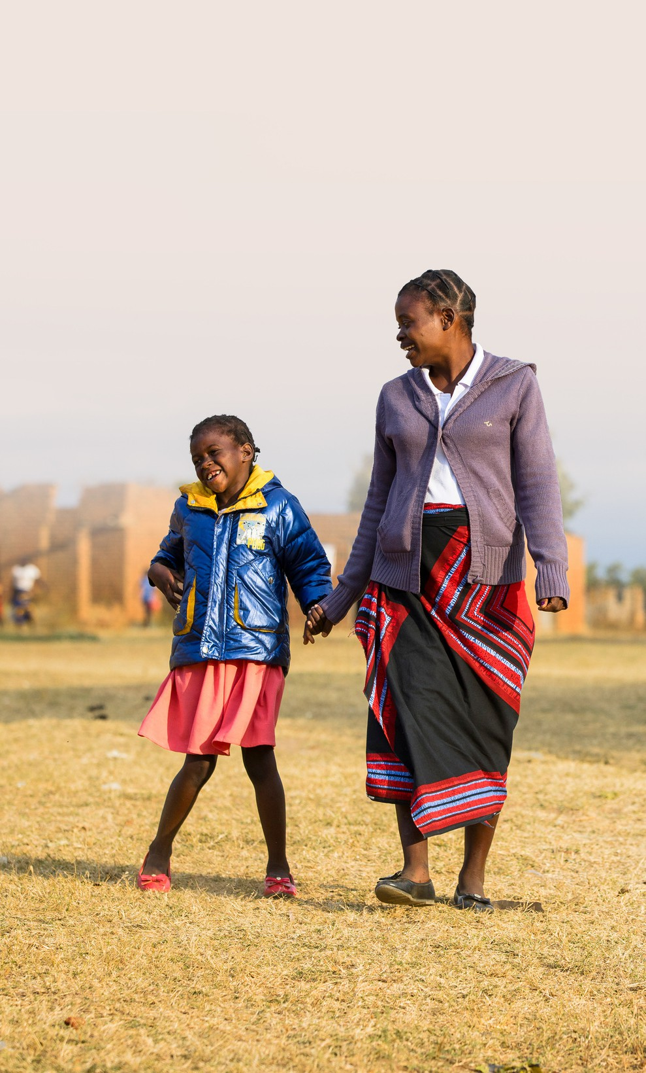

### We are a small and dynamic charity, entrepreneurial in style and collaborative in process. We are values led, passionate about our Network approach and driven by the communities with work with.

We are experts in what we do and are passionate about the approach we take. We are bold and agile and use the expertise we have built up over the last 40 years to make lasting change for children with disabilities in Africa.

We work hard for what we believe in but create an enjoyable, flexible and accessible working environment to ensure you enjoy what you do and have a good work-life balance, caring about your mental health.

We aim high in both our values and quality of our work. We strive to be the best at what we do, and use our strengths as a small organisation to innovate and showcase ideas for change.

We want to be better. We are honest about what we get wrong and provide space to make things right.

So come and join us!

# Our values

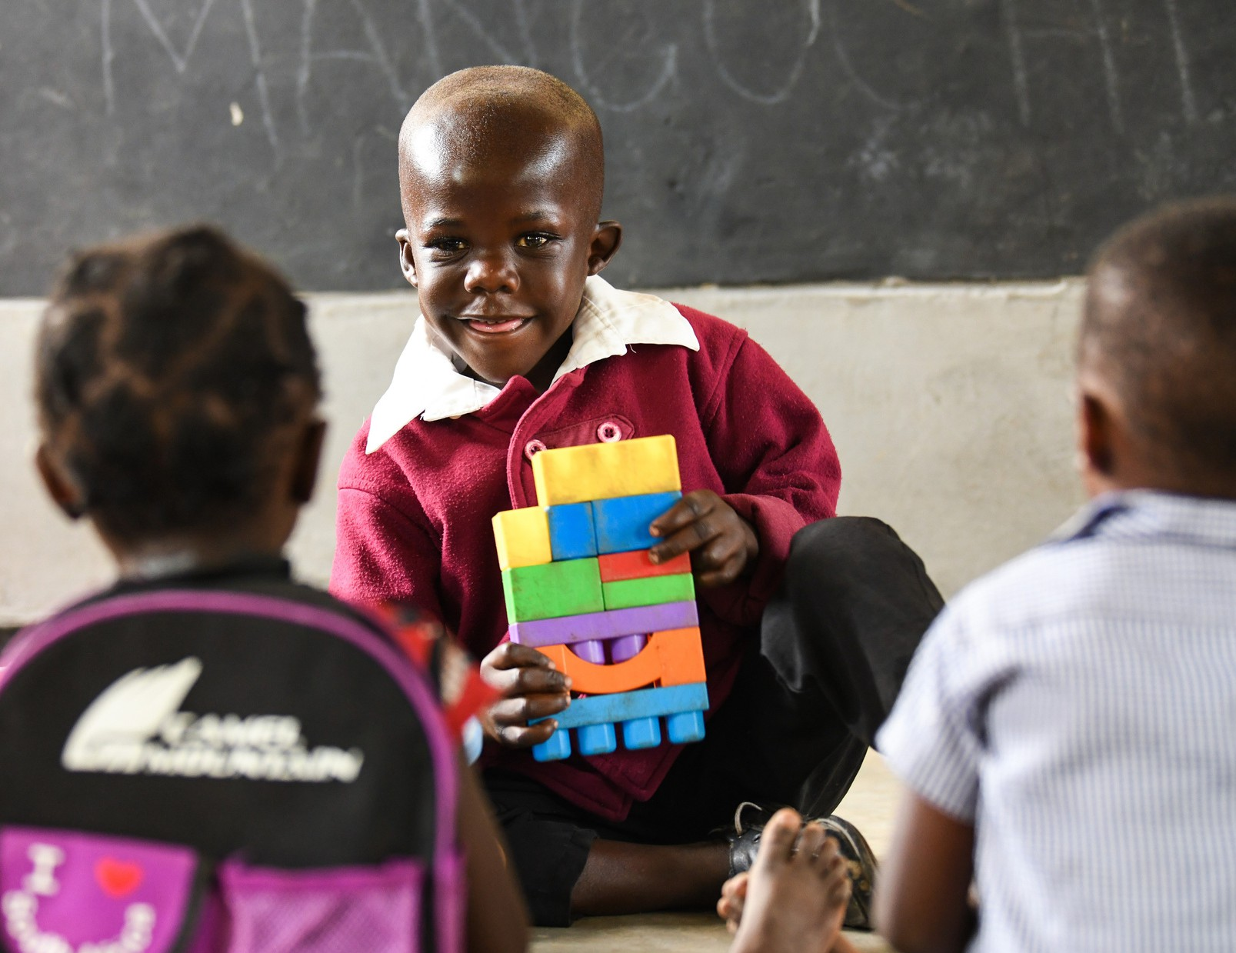

## We are led by three core values that define how we work and how we're run.

**Collaborative**

We believe we can achieve more by working together.

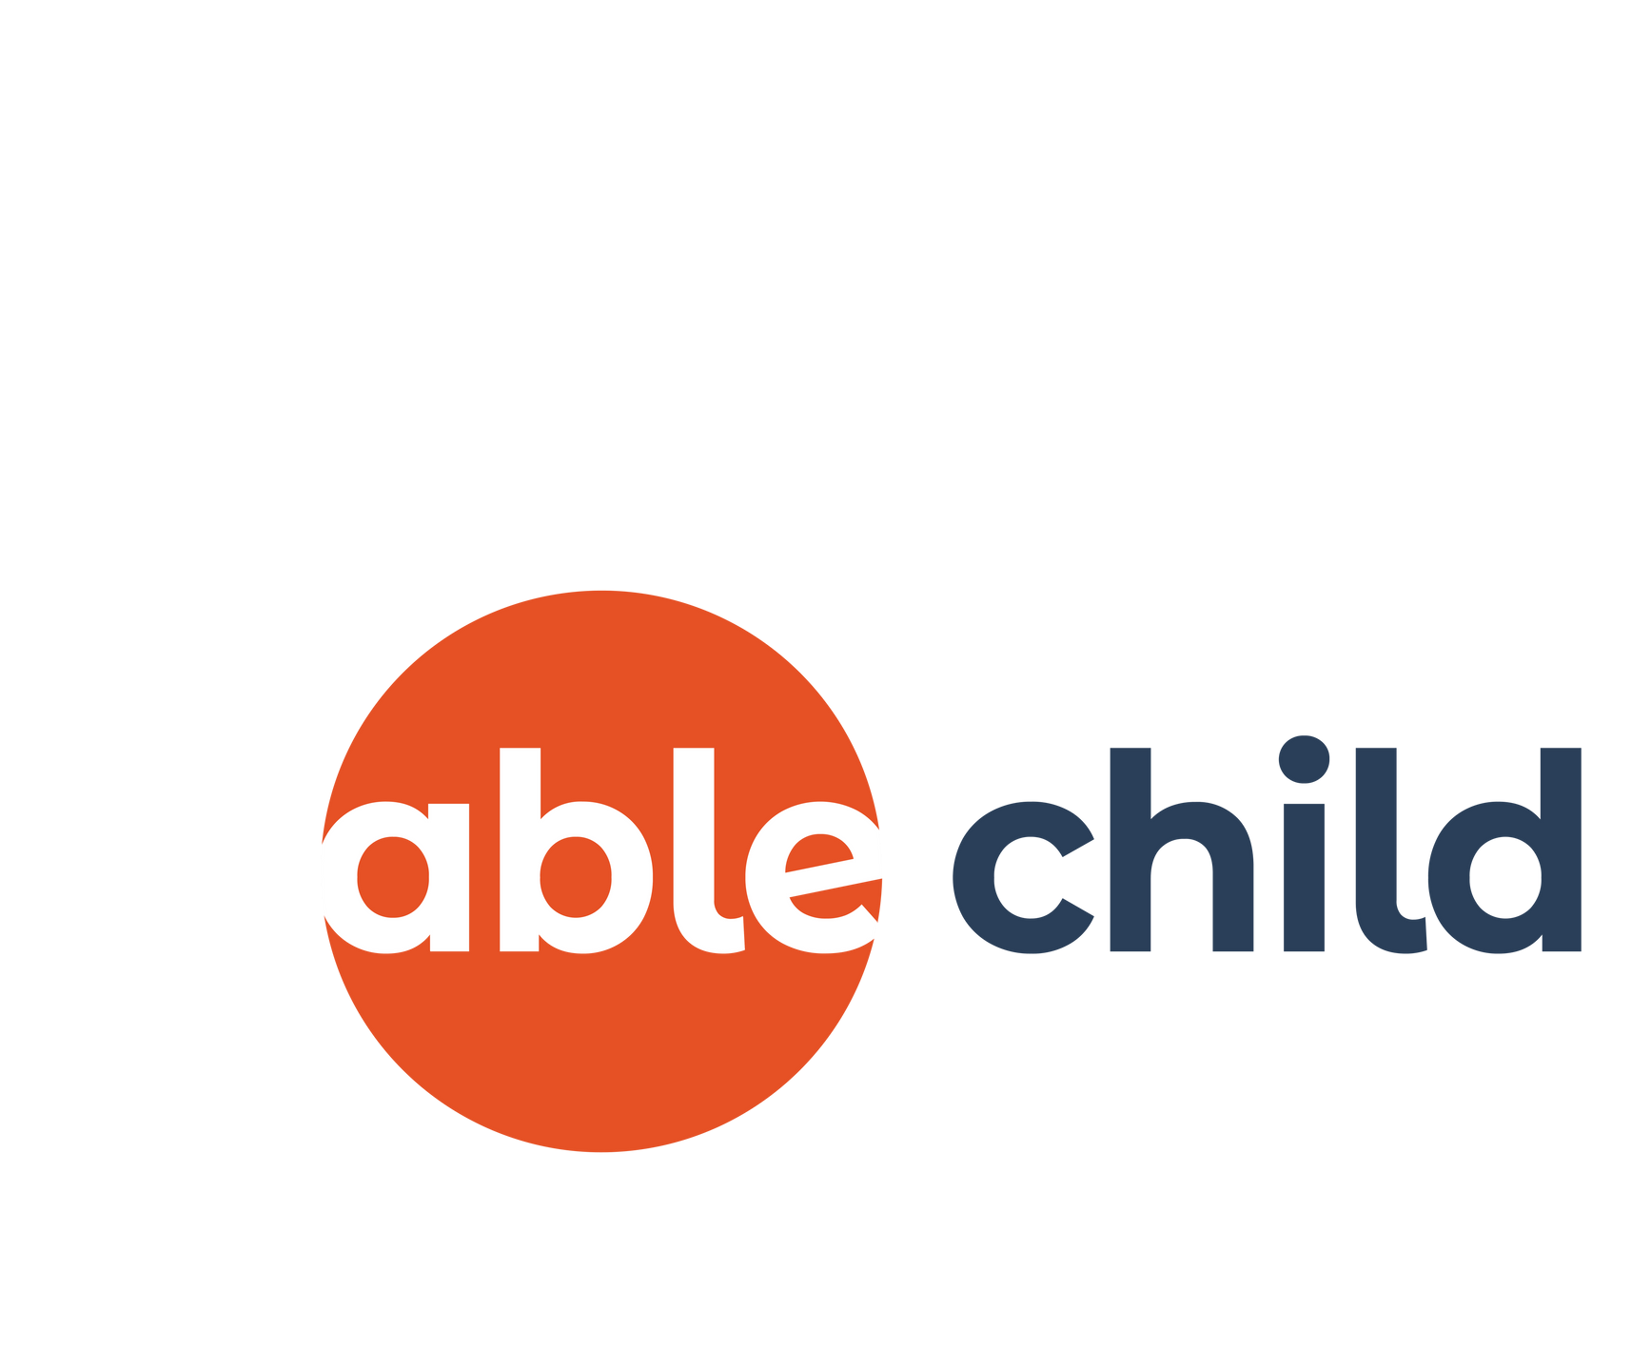

## Courageous

We are bold and agile, with the courage to innovate.

## Accountable

We are accountable to the children we work with.

# About the role

### This is an exciting time to join Able Child, having recently launched our new 2030 strategy. If you have experience working with partner organisations to secure funding for programmes overseas, alongside a strong belief in disability-inclusive development, then we would love to hear from you!

Working within our Programmes Team, you will secure over £200k of new income for each financial year to fund disability-inclusive programmes from a range of donors.

You will build relationships with corporates, trusts and foundations, institutional donors and other consortium partners, researching and identifying new funders and new opportunities whose strategic objectives and focus areas are aligned with our own.

You will work collaboratively with the Programmes Team and our Network members in Africa to develop and write compelling and high-quality proposals. You will develop new projects, MEAL plans and multi-year budgets.

You will work both independently and collaboratively to develop proposals. With excellent time management and organisational skills, you will demonstrate the ability to deliver quality work and meet deadlines, while managing a varied workload.

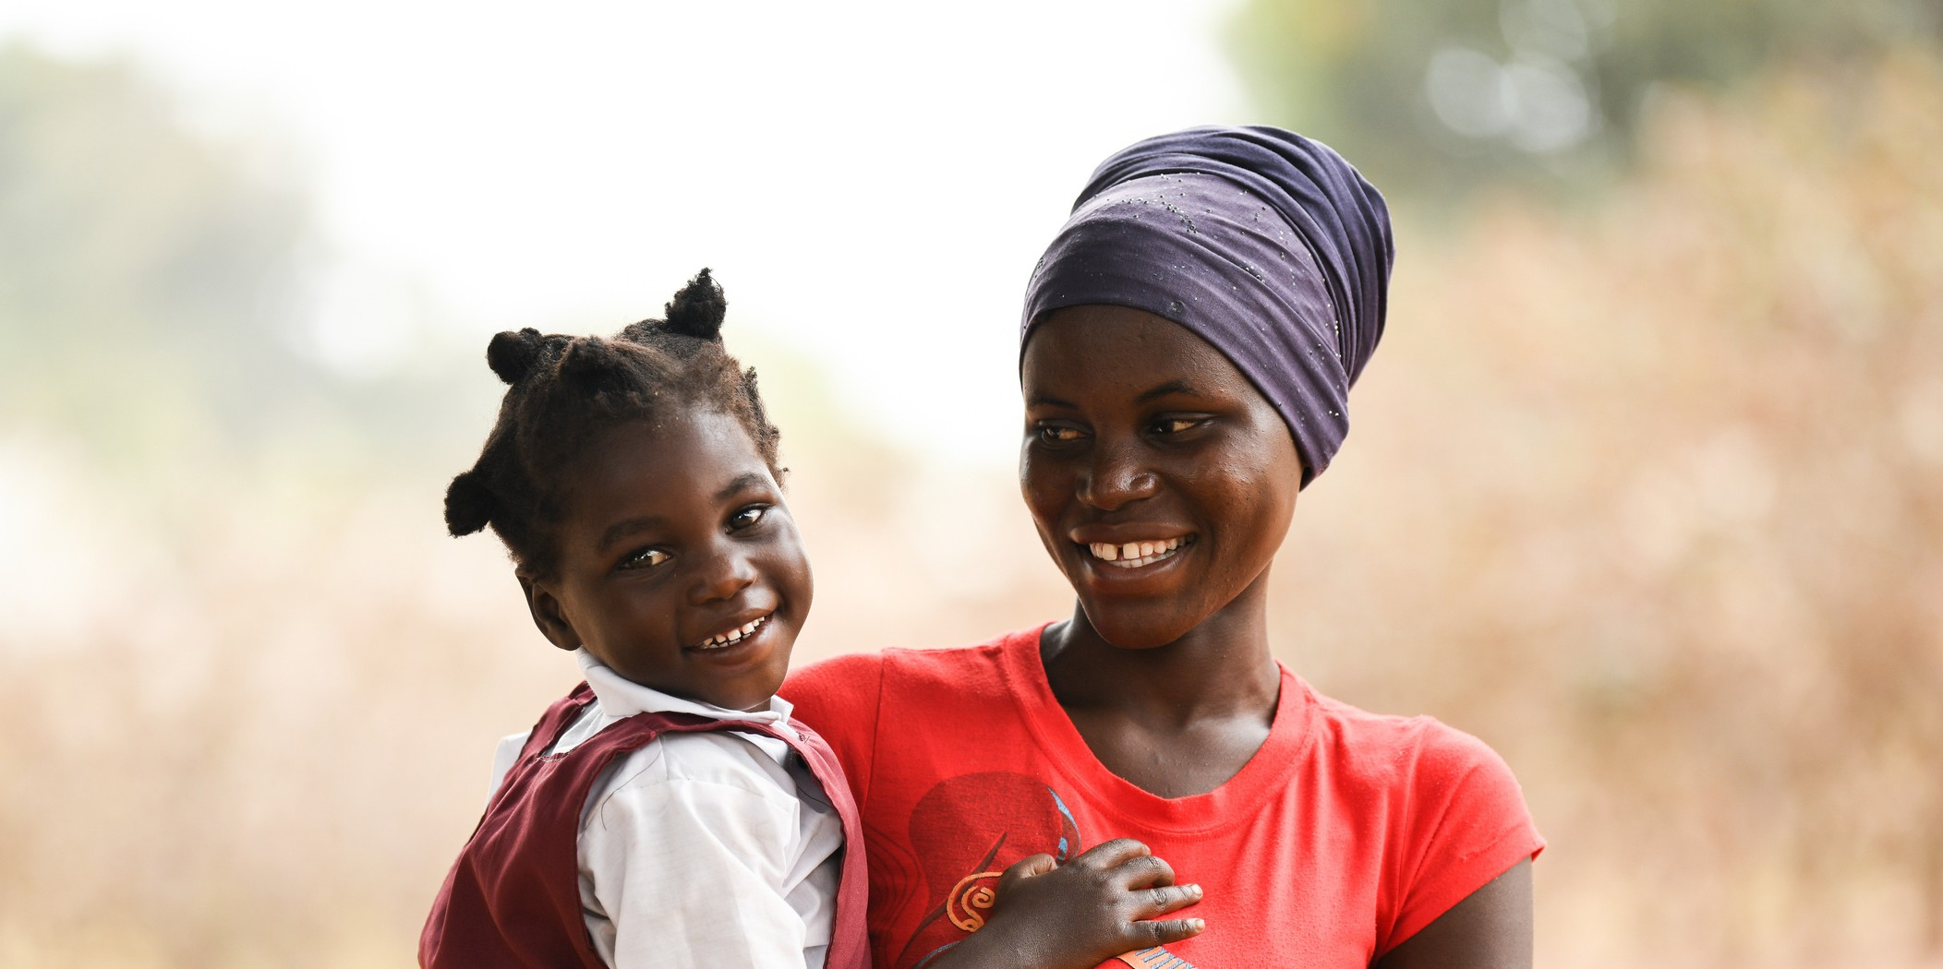

# About you

### We are looking for a passionate, creative and self-motivated individual, with excellent written and verbal communications skills, to join our Programmes Team at a pivotal time in the organisation.

You will have at least two years’ experience working in a similar role, ideally for an international development charity.

You will have experience in designing projects alongside civil society organisations overseas and developing applications for grants-based funding.

You will have a commitment to local civil society strengthening and ideally have experience in fundraising for disability- inclusive development.

Able Child is looking for a candidate who can demonstrate a proactive approach to researching potential funders and developing projects and proposals, with excellent communication skills.  
  
Able Child offers opportunities for career progression, and we seek a dedicated individual who can potentially advance within the role, based on their success, eventually taking on greater responsibility within our restricted fundraising team.

If you think this is you then we would love to hear from you!

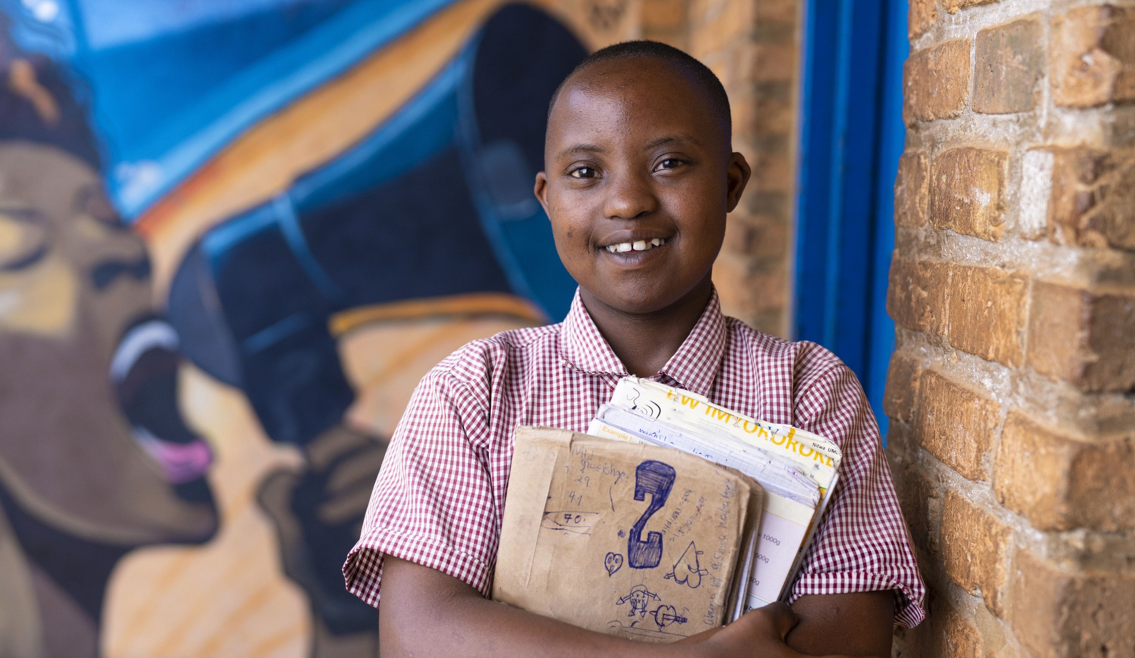

# Working for us

### We really like the people that work for us. They are our best asset and without them, we wouldn’t be able to do what we do. We have worked really hard to create a flexible and rewarding working environment that enables our team to deliver the quality of work that we strive for.

However, we recognise the workplace can be a stressful environment. Our staff are passionate about what they do, work hard and are invested in the people that we support. All of which can impact on daily wellbeing of staff. We believe that the mental health and wellbeing of anyone that works for us is of primary importance. We are therefore committed to promoting positive health among all our staff and volunteers, supporting those that need it and challenging stigmas against mental ill-health that exist in the workplace.

**Work-life balance:**

**Pension:**

**Family-friendly:**

**Flexible working:**

**Career development:**

**Inclusivity:**

Annual leave is 25 days a year pro rata (increasing to 26 days after two years and 27 days after five years of service), in addition to UK public holidays and an additional three days between Christmas and New Year.   
  
Able Child will pay a matching contribution capped at five percent agreed by you from your basic salary into Able Child’s workplace pension scheme.

Able Child offers enhanced birth parent leave and pay, enhanced non-birth parent leave and pay and enhanced shared parental leave and pay. Able Child also offers the same adoption or surrogacy leave and pay options as the birth and non-birth partner leave options.

Able Child employees are contractually based in the office, however we currently operate a hybrid working model requiring a minimum of two days in the office per week, subject to change. We promote a flexible working policy, enabling staff to manage their hours and time effectively.

Able Child offers is committed to supporting the professional development of its staff. This includes, but is not limited to, training opportunities and a personal training budget.

Able Child is committed to establishing and developing equality of opportunity for all. We are committed to making reasonable adjustments and will support staff to receive the support and adjustments they need.

## Responsibilities

### Build and maintain professional relationships with a range of key donors identified who are aligned with our mission and strategy to secure future income.

1. Focusing on medium to large donors, identify, research and approach new donors whose strategic objectives and focus are aligned with our own, including large trusts and foundations, institutional donors, corporate donors, and consortium groups.
2. Develop and foster long-term relationships with these donors through regular communication.
3. Through these relationships, identify relevant funding opportunities, working with Network members to identify opportunities where Able Child is able to add value as a delivery partner, or where Network members would be able to apply as lead grant-holders themselves.

### Co-design new and innovative projects for funding alongside our Network members.

1. Support the development of new and innovative projects, working alongside the Programmes Team and Network members in Africa to design theories of change, MEAL frameworks and workplans. This may also involve travel overseas as required (no more than 10 weeks per year) to work together with Network members to develop new project ideas.
2. Co-develop project budgets, reviewing local costs, supporting network members in accurate budgeting for activities and applying principles of full cost recovery.
3. Develop and maintain a portfolio of planned but unfunded projects, to attract prospective funders.

### Secure long-term grant funding to support new and existing projects in Africa.

1. Lead on the planning, coordination, and development of all funding bids for project delivery.
2. Working independently and with the Programmes Team, write and submit high quality and compelling applications to corporates, trusts and foundations, and institutional donors.
3. Secure large scale funding for projects across our network, delivering against annual restricted fundraising targets and bringing in over £200k of new funding for each financial year.

### Maintain a comprehensive and up-to-date donor database and funding pipeline.

1. Using our internal systems and Salesforce, maintain a comprehensive and up-to-date database of funders, including information on funding opportunities, donor requirements, dates and deadlines, applications made and secured income.
2. Develop and maintain an accurate grant funding pipeline, ensuring a healthy pipeline of prospective funding opportunities.
3. Provide quarterly reports to the senior management team on the current fundraising pipeline and the success of the fundraising plan to date.

### Provide operational and strategic support to the Fundraising and Communications Team as agreed, including routine office operations.

1. Assist the Fundraising and Communications Team with the delivery of other fundraising events and campaigns, as required.
2. Support other organisational and programmes activities and administration tasks as requested by your manager.
3. 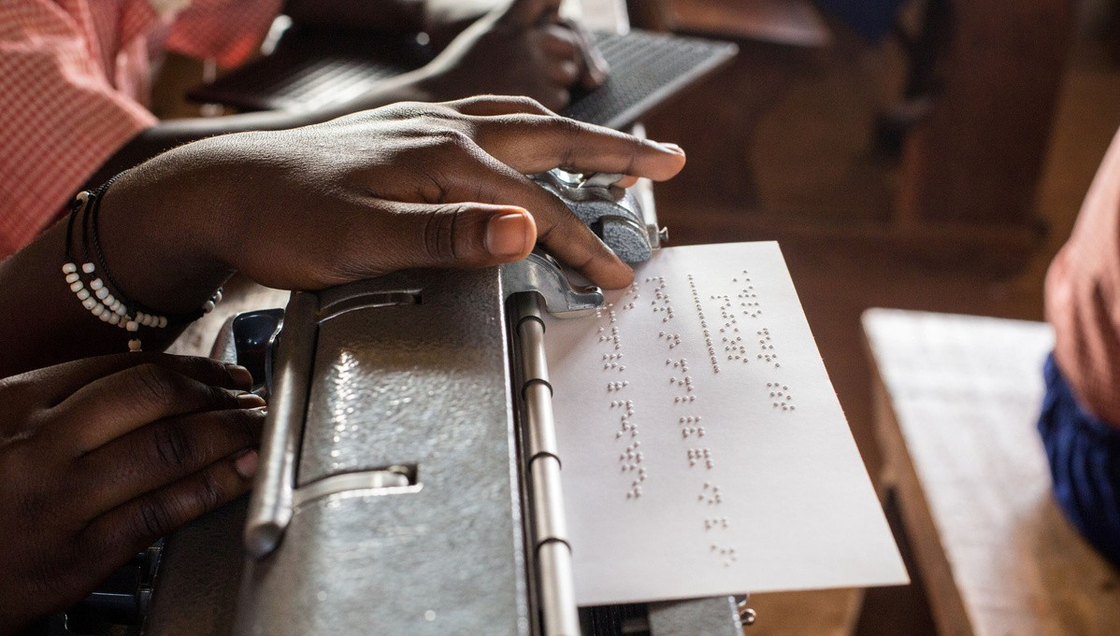Assist where necessary with ongoing skills development of Able Child’s Network members in Africa, supporting where possible with the development of proposals.

## Competencies

### Please outline your suitability to the following competencies in your Cover Letter. If you do not match one of the competencies, attempt to explain similar experience or skills you have.

Experience

* 1. At least two years’ experience in a similar role, with a demonstrable track record of securing five and six figure funds from a range of funding bodies.
  2. Experience in identifying and researching donors for programme delivery.
  3. Experience working with organisations overseas to design and develop project ideas and tailoring these for donor proposals.

### Skills and technical competencies

* 1. A clear understanding of the international development funding environment and donor expectations, with exceptional proposal development and writing skills, alongside an understanding of the issues affecting children and young people with disabilities in Africa.
  2. Strong budgeting skills, including full cost recovery, accurate forecasting, understanding exchange rate fluctuations and value for money principles.
  3. Good understanding of monitoring, evaluation, accountability and learning (MEAL), including designing theories of change and logframes for project design, delivery and donor reporting.

### Qualities

* 1. An understanding of contributing to an organisational culture based on inclusivity, wellbeing and empowerment.
  2. Excellent time management and organisational skills; ability to work under pressure to prioritise and manage a varied workload and competing deadlines, whilst ensuring attention to detail.
  3. A flexible working style and ability to work both independently and collaborate with others, as part of a te

## How to apply

If you think you are interested, please send your CV and a Cover Letter (no more than two sides of A4) that covers the key competencies, explains your suitability for the role and why you want to work for Able Child to [jobs@ablechild.org.uk](mailto:jobs@ablechild.org.uk) by midnight 5 September 2024 to apply.

To avoid disappointment, you are advised to submit your application as soon as possible as we reserve the right to close the vacancy early if a high volume of applications are received.

We may interview candidates on a rolling basis depending on the applications received, otherwise in-person interviews are expected to take place the week commencing 9th September.

Please note that you must have the right to work in the UK as Able Child is unable to provide sponsorship.



Able Child is an equal opportunities employer and will not discriminate against any candidate on the basis of any characteristic protected by the Equality Act 2010. We actively encourage applicants from all backgrounds. We particularly encourage applications from people with disabilities and people with direct experience of living or working with children with disabilities. All applicants with a disability who meet the minimum criteria will be offered an interview.

+44 (0) 20 7733 6006

[info@ablechilda.org](mailto:info@ablechilda.org)   
a[blechildafrica.org](https://www.ablechild.org.uk/)

34 Ponton Road, Nine Elms, London, SW11 7BA

Able Child Africa is a registered charity No. 326859 and a company limited by guarantee. Registered in England and Wales No. 1861434 registered at the above address.