

**Fundraising and Communications Executive**

# Job Pack - August 2024

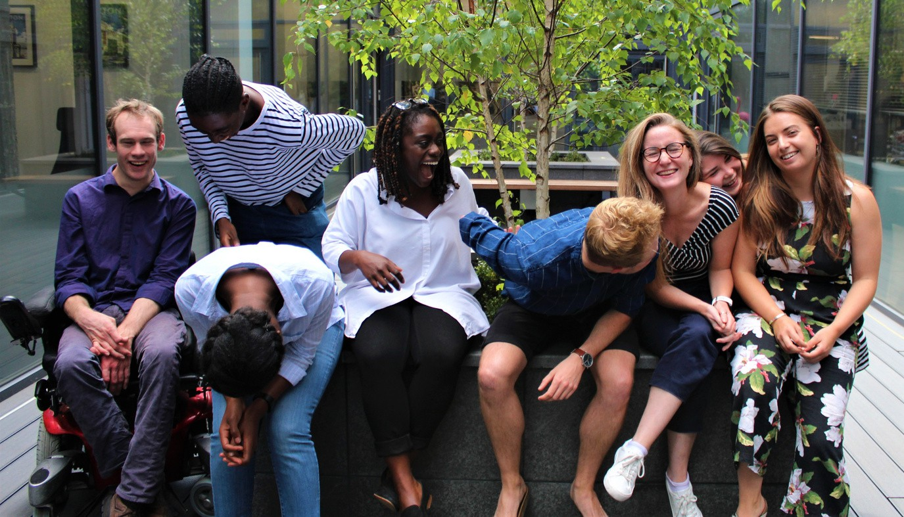We are looking for a new member to join the Able Child fundraising team!

We actively encourage applicants from all backgrounds. We particularly encourage applications from people with disabilities or with direct experience of living or working with children with disabilities. All applicants with a disability who meet the minimum criteria will be offered an interview.

We are a small, inclusive team that cares passionately about diversity and representation, but we acknowledge we can always be improving.

We also encourage applicants from African diaspora or heritage and people from Black, Asian and ethnic minority backgrounds.

**Working for children with disabilities in Africa**

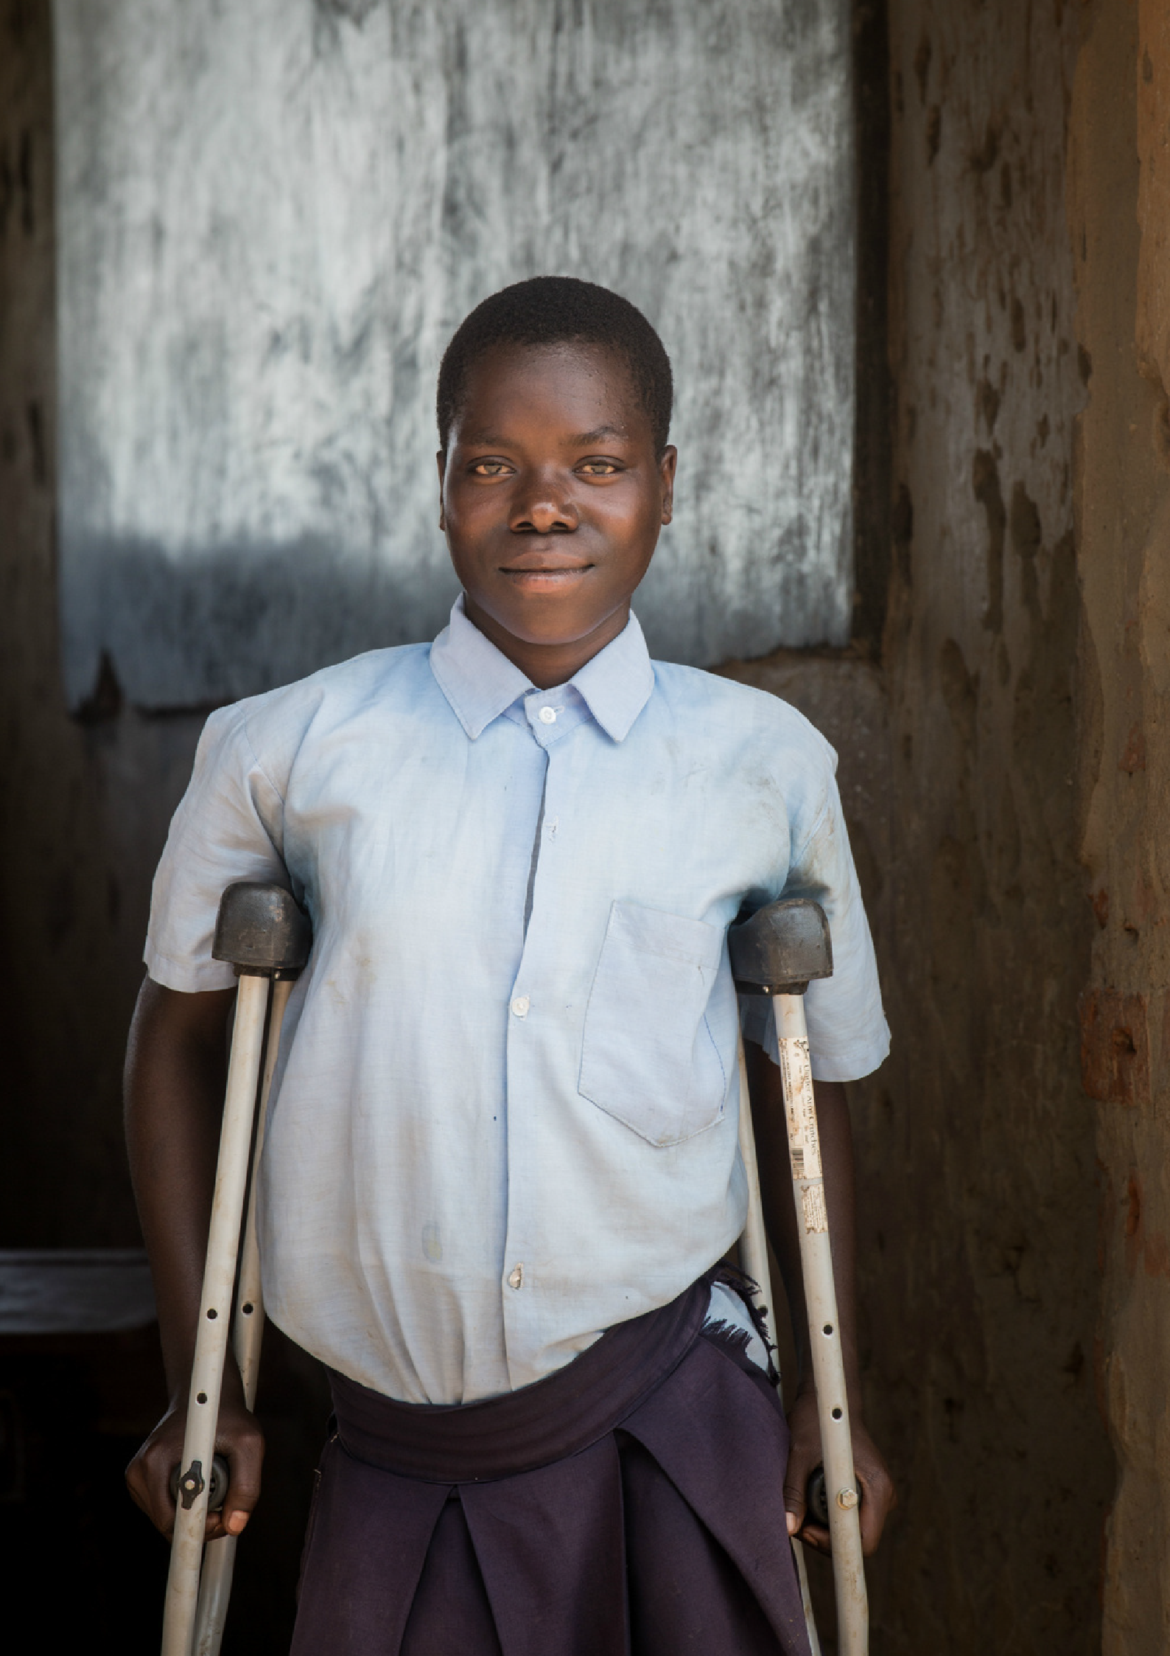

# About us

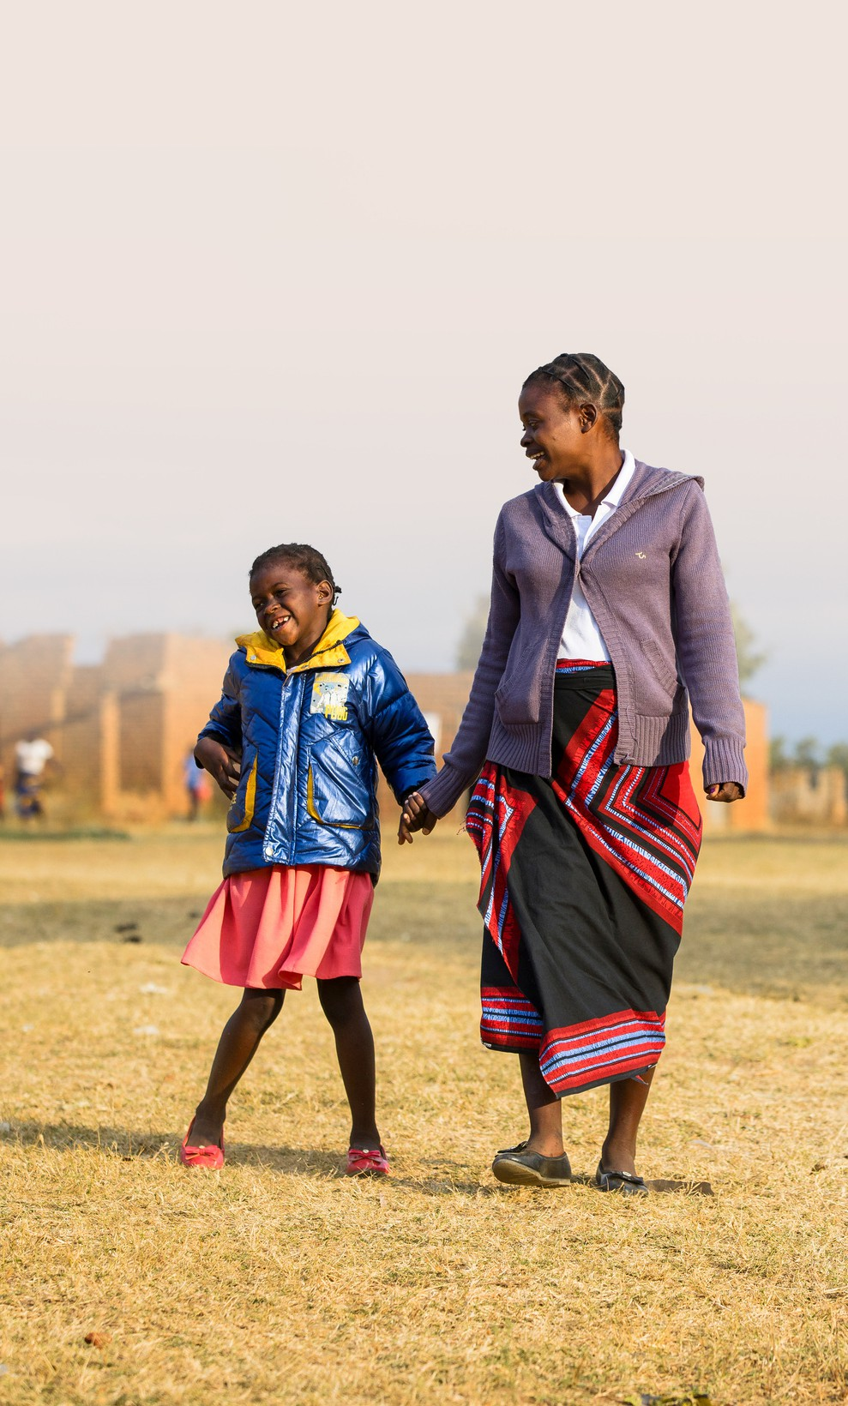

## We are a small and dynamic charity, entrepreneurial in style and collaborative in process. We are values led, passionate about our Network approach and driven by the communities with work with.

We are experts in what we do and are passionate about the approach we take. We are bold and agile and use the expertise we have built up over the last 40 years to make lasting change for children with disabilities in Africa.

We work hard for what we believe in but create an enjoyable, flexible and accessible working environment to ensure you enjoy what you do and have a good work-life balance, caring about your mental health.

We aim high in both our values and quality of our work. We strive to be the best at what we do, and use our strengths as a small organisation to innovate and showcase ideas for change.

We want to be better. We are honest about what we get wrong and provide space to make things right.

So come and join us!

**Our values**

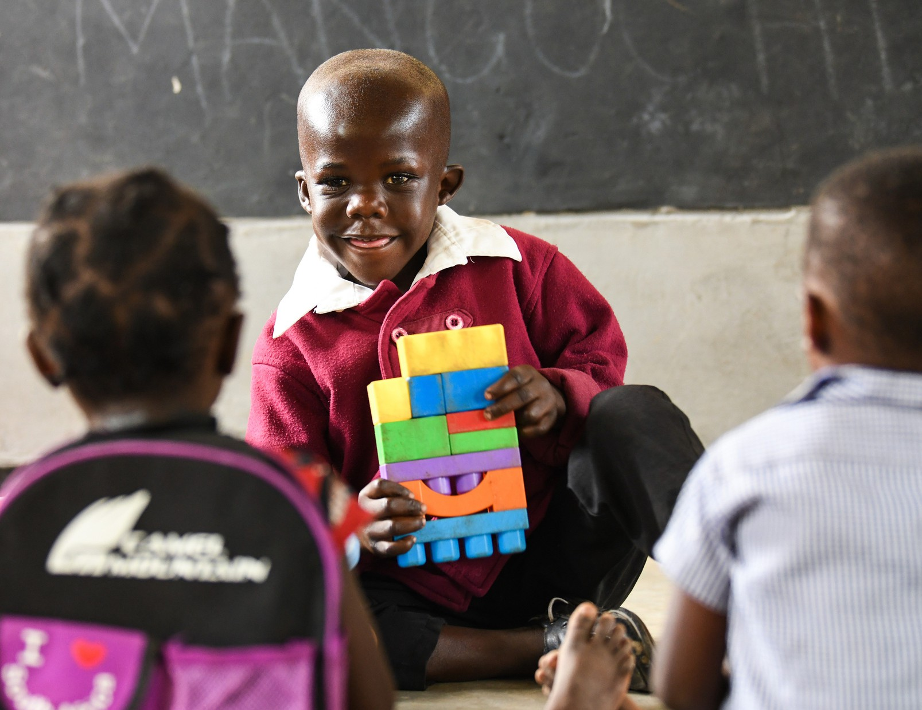

# We are led by three core values that define how we work and how we're run.

Collaborative

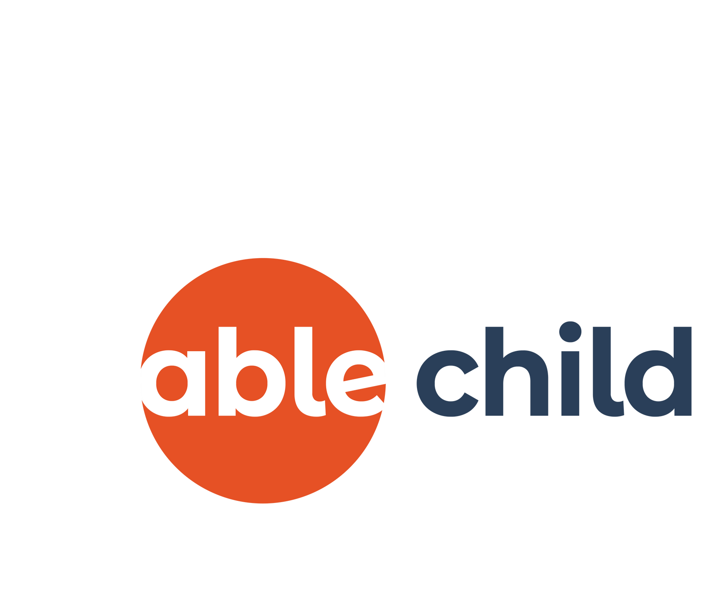We believe we can achieve more by working together.

# Courageous

We are bold and agile, with the courage to innovate.

# Accountable

We are accountable to the children we work with.

# About the role

## Working within our fundraising and communications team, you will support our communications portfolio of work. Maintaining our consistent brand, you will lead on digital and print asset development.

You will lead on supporter communications, raising the profile of the organisation and attracting new supporters into the charity.

You will manage our social channels, website content and newsletter, and develop creative assets and materials for our external work both in the UK and the US.

You will also support on fundraising within the organisation, gaining experience across a wide variety of income generation areas. This will typically focus on applications to small Trusts and Foundations, the delivery of our events and the implementation of our individual giving programme.

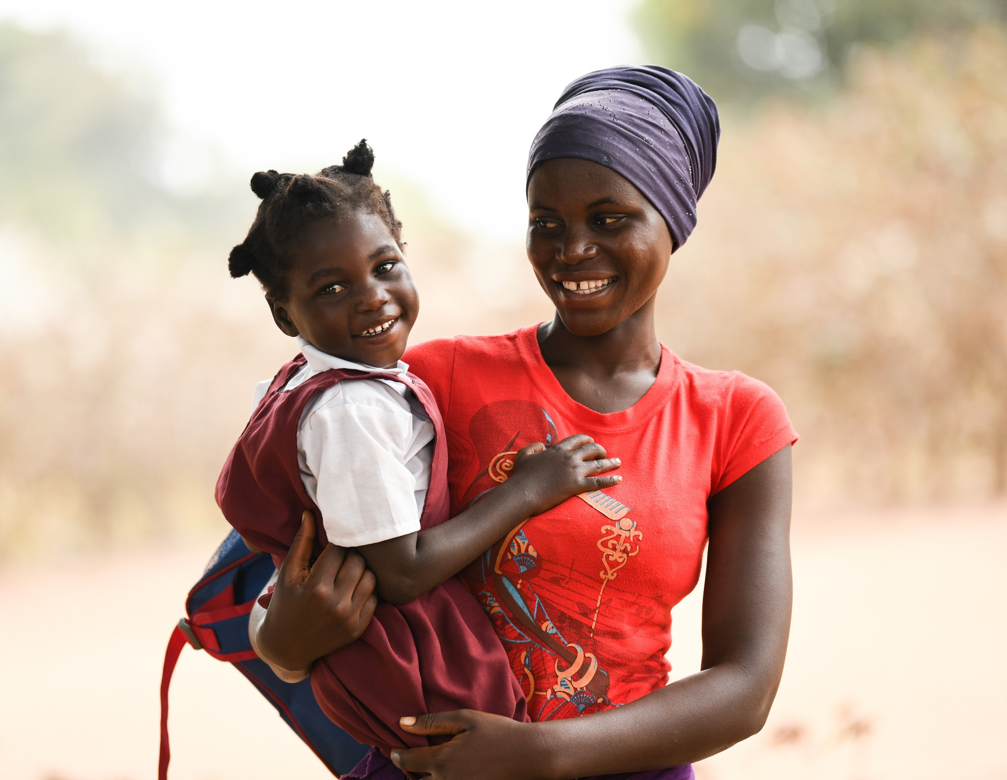

# About you

## We are looking for a passionate, creative and self-motivated individual to join our Fundraising and Communications Team and help shape our future so we are able to reach more children with disabilities in more countries.

You will work both independently and collaboratively develop creative assets for events and activities.

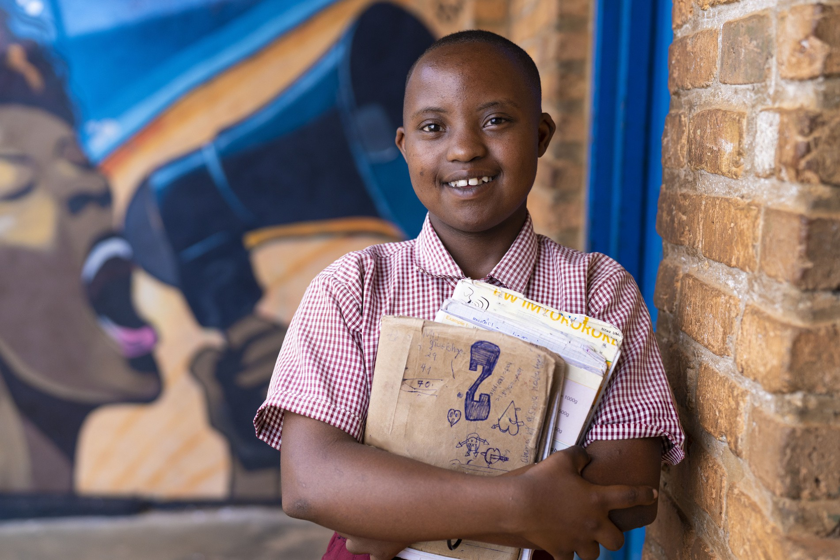With excellent time management and organisational skills; you will demonstrate the ability to deliver quality work and hit deadlines, while managing a varied workload.

We seek a self motivated and hardworking individual who can drive forward targets.

Most importantly you will have a belief in disability-inclusive development.

If you think this is you then we would love to hear from you.

# Working for us

## We really like the people that work for us. They are our best asset and without them, we wouldn’t be able to do what we do. We have worked really hard to create a flexible and rewarding working environment that enables our team to deliver the quality of work that we strive for.

However, we recognise the workplace can be a stressful environment. Our staff are passionate about what they and the people that we support. All of which can impact on daily wellbeing. We believe that the mental health and wellbeing of anyone that works for us is of primary importance. We are therefore committed to promoting positive health among all our staff and volunteers, supporting those that need it and challenging stigmas against mental ill-health that exist in the workplace.

**Location:**

**Hours: Term: Reporting to:**

**Salary range: Annual leave:**

**Pension:**

Nine Elms, Central London – current requirement is to be in the office a minimum of two days a week between Monday and Thursday

Full time, 37.5 hrs week (open to reduced hours if desired) Permanent

Head of Fundraising and Communications

£27,534 to £30,400

25 days per annum, plus an additional 3 days between Christmas and New Year.

Matched to 5% with to organisation’s pension provider.

If you are interested, then send your CV and a Cover Letter (two sides of A4) that covers the key competencies, explains your suitability for the role and why you want to work for us to [jobs@ablechild.org.uk](mailto:jobs@ablechild.org.uk) by midnight on Friday 30 August 2024.

Interviews will take place on a rolling basis.

# Responsibilities

## Assist the management of Able Child’s brand and external communications, with high quality content.

1. Manage Able Child’s social channels, working with external suppliers when applicable, to maintain a professional and engaging external brand.
2. Support the management a vibrant and responsive website by ensuring content is up to date, professional and engaging; supporting the collective of imagery, videos, blogs, utilising external suppliers where directed.
3. Produce and distribute the quarterly newsletter, contributing with high-quality content and complying with organisational data protection and confidentiality standards.

## Assist the management of our portfolio of fundraising events.

1. Assist the management of our events portfolio. This includes but is not exclusive to the London Marathon, Annual Gala, and Charity Golf Day.
2. Market the series of events, recruiting, retaining and communicating with participants to support the attainment of income targets.
3. Support with donor stewardship activities post event, engaging new regular donors and supporters to grow our incomes streams.

## Assist the delivery of other fundraising work, including but not exclusive to trusts & foundations, individual giving and community fundraising.

1. Support the attainment of funds from a variety of trusts and foundations, through submitting high quality applications.
2. Support Able Child’s individual giving programme, assisting with donor communications, building relationships with donors and growing our income.
3. Support community fundraising activities, empowering existing and newly sourced supporters to independently generate funds through independent events and activities.

## Provide other support including routine office operations.

1. Maintain our Salesforce database, keeping detailed records of communications, support and donations from individuals and organisations.
2. Support our advocacy objectives, working with the Advocacy team to produce high quality and consistent messaging for use within the international development sector.
3. Support the delivery of unique and ongoing operational activities as required

# Competencies

## Please outline your suitability to the following 9 competencies in your Cover Letter. If you do not match one of the competencies, attempt to explain similar experience or skills you have.

Experience

* 1. At least one years’ experience in a fundraising, communications, marketing or sales support role or similar.
  2. Experience of managing or supporting the management of events to, ideally including managing volunteers or supporters to raise funds.
  3. Experience or knowledge of writing funding applications, ideally with a demonstrable track record of securing funds from trusts and foundations.

## Skills and technical competencies

* 1. Creative ability to assist in the production of engaging content for communication in line with the organisational brand and mission.
  2. Competency in managing social channels under direction, developing newsletters and other blogs or articles.
  3. Basic understanding of WordPress, and other design packages (Adobe Creative Cloud, Canva) desirable.

## Qualities

* 1. An understanding of contributing to an organisational culture based on inclusivity, wellbeing and empowerment.
  2. Excellent time management and organisational skills; ability to work under pressure to prioritise and manage varied workload and competing deadlines whilst ensuring attention to detail.
  3. Personable, with an ability to develop and maintain new relationships.

## Please send your CV and a 2-page cover letter to [jobs@ablechild.org.uk](mailto:jobs@ablechild.org.uk) by midnight on 30th August 2024 to apply.



Able Child is an equal opportunities employer and will not discriminate against any candidate on the basis of any characteristic protected by the Equality Act 2010. We actively encourage applicants from all backgrounds. We particularly encourage applications from people with disabilities and people with direct experience of living or working with children with disabilities and all applicants with a disability who meet the minimum criteria will be offered an interview.



+44 (0) 20 7733 6006

[info@ablechilda.org](mailto:info@ablechilda.org) a[blechildafrica.org](https://www.ablechild.org.uk/)

34 Ponton Road, Nine Elms, London, SW11 7BA

Able Child Africa is a registered charity No. 326859 and a company limited by guarantee. Registered in England and Wales No. 1861434 registered at the above address.